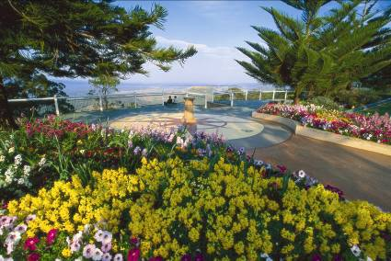
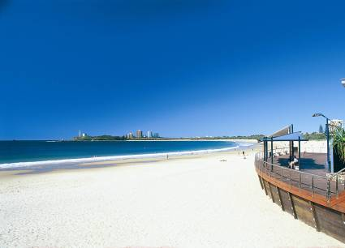
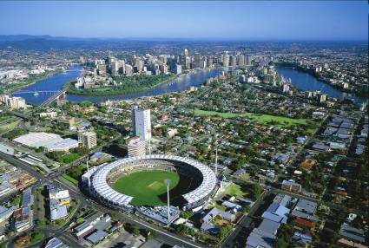
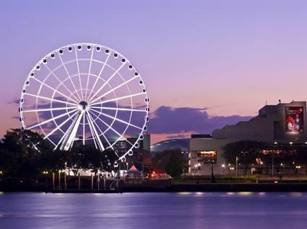

7 Day Hospitality Skills & English Study Tour Itinerary & Quote

Group: Vocational Student Participants
Referrer: Indonesia
Approx. No. of Students:
Approx. No. of Staff:
Probable Tour Dates:
AU$1690

Inclusions
- English classes as per attached itinerary.
- All excursion and activity fees as per attached itinerary.
- Transfers between airport and UIL campus on arrival and departure.
- Transport for all activities and excursions.
- Orientation kit on arrival.
- All stationary and tuition materials.
- Homestay accommodation including 3 meals per day.
- UIL staff member to accompany all activities and excursions.
- UIL Certificate of Graduation.
- Graduation gift.

Exclusions
- Airfares
- Personal expenditure and items of a personal nature.
- Activities and transfers arranged by the Agent
- Agent commission is not included in the quoted price, which is a net price.
- Travel/Health Insurance is not included in any of the prices quoted. Travel/health
insurance should be arranged for the duration of each student’s and tour leader’s stay
in Australia, a copy of which must be provided to the Australian institution.

Quotation Acceptance:
In signing acceptance of this quotation, the tour group agrees to behave in a manner
accepted as appropriate by the Australian institution and to abide by the schedule as
agreed to prior to the commencement of the tour. Any schedule changes must be approved
by management and may incur additional charges.

Name: ___________________________________ Signature: _______________________________

Short Version No. : 1
Date: 11/3/2018
Prepared by: Anne McDougall
Study Tour Itinerary

Day | Schedule
1  Sunday | Early Morning Arrival to Brisbane  Transfer to New Farm Park for a welcome breakfast.  Visit Mt Coot-tha for City Views and Tour of Brisbane City. Visit Lone Pine Koala Sanctuary to hold a koala and experience Australian Wildlife. Lone Pine Koala Sanctuary in Brisbane, is the world's first and largest koala sanctuary, with over 130 koalas. Cuddle a koala anytime, hand feed kangaroos and encounter a large variety of Aussie wildlife, all in beautiful, natural settings. www.koala.net for more information. 12pm Pray. Transfer to UIL for orientation and campus tour, BBQ Lunch at Robel Domain. Orion Shopping. (Money exchange and Sim cards if required). Homestay pick-up late afternoon.
2  Monday | English Class – hospitality focus
3  Tuesday | Welcome to TAFE Queensland – Southbank Campus Tour  Full Day: Hospitality Vocational Skills Workshop – Southbank Campus  PLEASE NOTE: Workshop skills to be taught will be determined according to group needs.  Afternoon visit to Southbank and Brisbane CBD. Southbank is well-known as the place to go for special occasions. It’s where Brisbane comes together to celebrate. With its large open areas, huge swimming lagoon and river front pathways. Southbank has become a popular gathering place. The Queensland Museum and Art Galleries at Southbank are world-class educational attractions at Southbank. Visit and observe Hospitality Businesses in main CBD setting.
4  Wednesday | Full Day Excursion: Visit the famous tourist destination the Gold Coast – beautiful beaches and great shopping. Enjoy sightseeing and Harbourtown shopping. The Gold Coast is world renowned tourist destination, famous for its beautiful white beaches. Enjoy Australian shopping at the wonderful Gold Coast shopping areas. Visit and observe Hospitality Businesses in tourist setting.
5  Thursday | Full Day: Hospitality Vocational Skills Workshop – Southbank Campus  PLEASE NOTE: Workshop skills to be taught will be determined according to group needs.  Afternoon visit to the University of Queensland and night Shopping at Indooroopilly Shoppingtown. Visit and observe Hospitality Businesses in shopping centre setting.
6  Friday | Business English Class. Discuss and compare different business settings that have been observed in shopping centres, Brisbane CBD and coastal tourist destinations.  Graduation – Farewell speeches and celebration  Afternoon and evening visit to Brisbane CBD for sightseeing and shopping.
7  Saturday | Depart for home country

Note: Changes to the itinerary may require a revised quotation.
Terms and Conditions:
Validity
- The quote is valid for a period of one year from the quote date.
- The quote agreement is only valid if signed and returned to UIL.
- Any changes to the itinerary may incur additional fees.
- Late night arrival or departure flight times may incur additional fees.
- UIL reserves the right to cancel an activity in circumstances outside its control e.g. activity cancellation due to bad weather. UIL will make every effort to provide alternative activities in consultation with the Tour Leader/s.
- UIL reserves the right to move activities around if activities are not available at the scheduled time or date.
- If rearrangement of schedules needs to occur all changes will be communicated to the tour group.

Accommodation
- Students will be accommodated with suitable Homestay families, as indicated in the Itinerary.
- Twin share means 2 students sharing the same bedroom. There may be other students in the home.
- The Homestay families will supply three meals per day.
- Homestay Application Forms must be received 4 weeks prior to arrival to ensure effective matching with appropriate families.
- A final accommodation list will be provided no earlier than 2 weeks prior to arrival.
- A change made to original sharing arrangements may incur an additional charge of $250.
- Any damage to Homestay property caused by students/tour leaders must be paid for by the student/tour leader.

Cancellation fees
- UIL will deduct 50% of the study tour quote for individual cancellation 1 week before the commencement date.

Payment
- A 25% Study Tour Deposit is due within 30 days of signing this agreement.
- The remaining 75% is due 1 month prior to arrival.
All payments should be made to the following account and email confirmation of payment sent to enquiries@uil.edu.au
Bank Name: | Commonwealth Bank of Australia
Bank Address: | 240 Queen Street, Brisbane, Queensland, 4000, Australia
Account Name: | Union Institute of Language – Springfield Campus Pty Ltd
BSB: | 064 000
Account Number: | 1116 1419
Swift ID Code: | CTBAAU2S

Further Information:
For more information regarding this UIL Study Tour Program, please contact: Anne.Mcdougall@uil.edu.au

